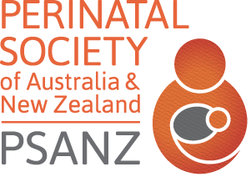
THE PERINATAL SOCIETY OF
AUSTRALIA & NEW ZEALAND
www.psanz.com.au

Eligibility for PSANZ Neonatal Nursing/Midwifery Award
NURSING/MIDWIFERY MANAGER ENDORSEMENT FORM

Nominee Name:
Nominee email, Ph. # or other contact details:
Membership Discipline (Select ONE of): Midwifery / Neonatal Nursing / Both

The above nominee confirms that (please check boxes to confirm):
They are a current financial member of PSANZ
They led the project (may have been other team members involved)
They are the first author AND presenter of the submitted abstract
They have only nominated 1 abstract for consideration for a Nursing/Midwifery award
They will be present at the closing ceremony when the awards are announced
They have not been awarded a PSANZ New Investigator Award (NIA) previously
They have not been 1st author on an abstract or publication dated earlier than past 5 years
They do not hold hold a university academic appointment higher than Level B (Tutor,
Lecturer, Research Fellow), or a university adjunct appointment higher than Adjunct
Lecturer or Adjunct Research Fellow

The project the nominee led and will present at PSANZ is best described as: (select project type- more than one type can be selected if applicable):

Quality improvement/assurance (QI/QA) project that led/would lead to practice change in their perinatal clinical area. Examples include: audit of existing midwifery or nursing practice, Agency for Clinical Innovations Essentials of Care project
Education initiative that was piloted, introduced and evaluated in their perinatal clinical area
Trial of a new product/policy/guideline in their perinatal clinical area
Nurse or midwife led project
Research project conducted within a research higher degree

Ethical approval received: Yes No Not applicable

Applicant Signature Date / /
Manager Signature Date / /
Manager Name / Contact Telephone number

***Please upload completed form with online submission.

